***Experiment 9 Output***

**Aim:** This experiment simulates AWS CloudWatch logging using **Docker, LocalStack, and AWS CLI**. It involves setting up log groups, streams, and sending log events locally. This enables monitoring and testing without an actual AWS account.

***Starting Localstack***

***Starting Docker***

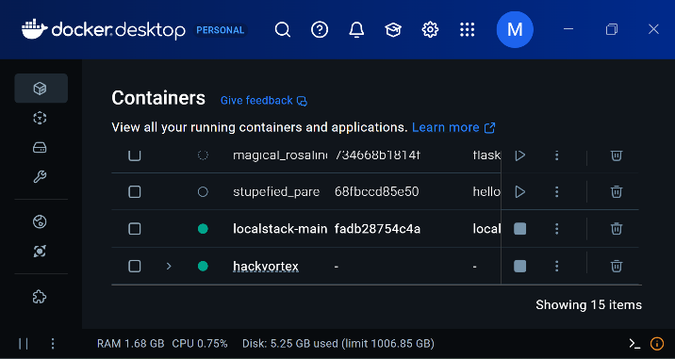

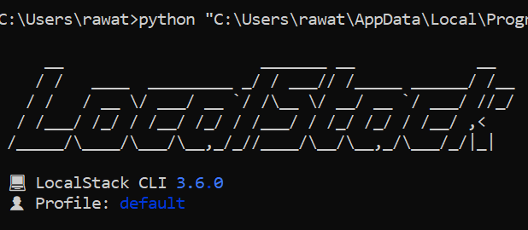

**Fig 2: Starting Localstack**

**Fig 1: Starting Docker**

***Listing Metrics***

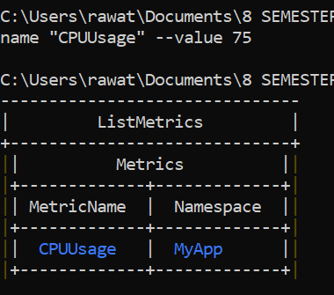

***Creating Logs and Putting time stamps in logs***

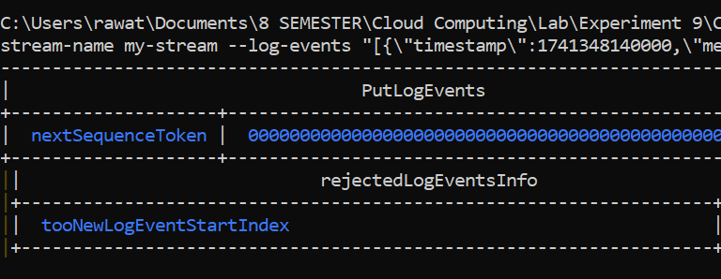

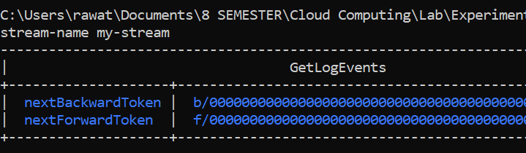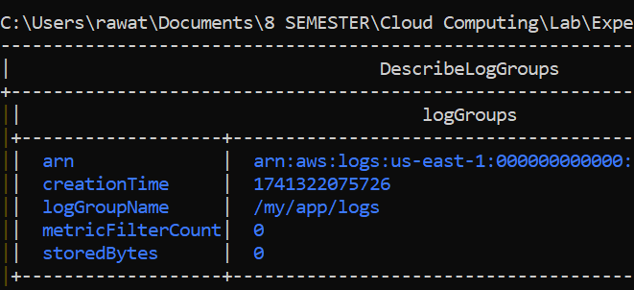

***Log Events***

***Fig 4: Metrics List***

**Fig 3: Logs Table**

***Fig 6: Log Events Table***

***Describing Log Groups***

***Fig 5: Log Group Table***